
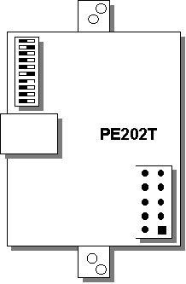

Installation, Operation & Diagnostics

for the

PE202T-N

Pony Express Modem Module

TABLE of CONTENTS

- STANDARDS Page 2

- PRODUCT OVERVIEW Page 3

- GENERAL PRODUCT SPECIFICATIONS Page 4

- MODEM SPECIFICATIONS Page 5

- ANALOG LINE SPECIFICATIONS Page 7

- ANALOG MICROWAVE SPECIFICATIONS Page 8

- CONNECTOR PIN-OUTS Page 10

- DIP SWITCH FUNCTIONS Page 11

- MODEM CONFIGURATION Page 13

- OUTLINE DRAWING Page 14

- DIAGNOSTICS Page 15

1. STANDARDS

Meets FCC Rules Part J, Subpart 15, Class A for radiated emissions.

2. PRODUCT OVERVIEW

The PE202T Modem Module is an industrial grade Bell 202T modem for connection to unconditioned and conditioned, voice grade, type 3002 two or four-wire leased lines and metallic conductors (eg; pilot wires). It is powered from 5.5 to 9VDC unregulated or +5VDC regulated, is surge protected on the analog and digital connections, and will operate in temperatures from -40 to +85 deg C.

The PE202T module is supplied to OEMs for integration into relays, controllers, RTUs, etc. The data interface can be either RS232 or TTL.

The PE202T is also at the heart of all Telenetics Bell 202T end-user products such as the MIU202T standalone modem and the Myriad MDR/PE202T rack mount modem bank.

3. GENERAL PRODUCT SPECIFICATIONS

Dimensions: See Section 10

Voltage Supply, Data Interface & Current Requirements:

Model No. | Voltage | Data Interface | Current
PE202T-N0 | +5.5 to 9VDC | RS232 | 47 mA
PE202T-N1 | +5.5 to 9VDC | TTL | 28 mA
PE202T-N2 | +5VDC ± 5% | RS232 | 47 mA
PE202T-N4 | +5VDC ± 5% | TTL | 28 mA

Surge Protection: Analog Line: 3.75kVAC
Digital Line: ESD ± 10kV

Operating Temperature: -40 to +85 deg C
Operating Humidity: 0 to 90% (non-condensing.)
Storage Temperature: -55 to 100 deg C

4. MODEM SPECIFICATIONS

Modulation: Bell202T
Modulation Type: FSK

Synch/Async: Asynchronous Only

Data Rate: 0 – 1200bps

Transmit Frequency: Mark: 1200Hz
Space: 2200Hz

Error Correction: None
Data Compression: None

Data Modulation Connectivity: Using 16ms Polling Test

99.999% or better at -37dBm
99.5% or better at -40dBm
95% or better at -43dBm

Serial Formats and Flow Control:

Asynchronous and RTS/CTS flow control

Analog Interface

Tx Output Level: -0 dBm or -10 dBm *
Rx Sensitivity: -43dBm or -33dBm *
-43dBm for constant carrier
-40dBm for polling carrier
Line Termination: Dip Switch Selectable *
Line Impedance: 600 ohms balanced
2 or 4 Wire Configuration: Dip Switch Selectable *

Other Features

Receiver Equalization: Compromise Equalization
Self Test Diagnostics: None
Local Analog Loopback: See Section 13
Local Digital Loopback: See Section 13
Remote Analog Loopback See Section 13
Remote Digital Loopback See Section 13
Anti-Streaming: OFF or 45 Seconds (+ 5 sec) *
RTS/CTS delay: 1ms, 12ms, 35ms or 50ms (+5%) *
Note: Soft Carrier will affect RTS/CTS delay time (see Dip Switch Settings ~ Section 9)
Constant Carrier Switch Selectable ON or OFF *
Soft Carrier Turn Off 20ms of 900Hz after RTS is turned Off
Carrier Turn ON/OFF 8ms +0.5ms

* Dip Switch Selectable ~ See Section 9

5. ANALOG LINE SPECIFICATIONS

The PE202T contains analog circuitry for connection to the public conditioned or unconditioned, Bell type 3002, 2 or 4-wire, full duplex voice grade or metallic lines (eg; pilot wires). The PE202T will also interface to Power Line Carrier or Microwave radio voice channel networks.

The PE202T has an RJ-11 terminated connector. The following lists the PE202T analog interfaces

Analog Line Type:

Conditioned or unconditioned, Bell type 3002, 2 or 4-wire, full duplex voice grade or metallic lines or better.

Analog Line Specifications:

Bandwidth 300 Hz to 3400 Hz (±3dB)
Impedance 600 / 900 ohms , balanced
Frequency Response 400 to 3000Hz (±2dB)
Receiver Input Level -16dBm max.
Output Level +7 dBm
Noise Signal Level -48 dBmO

6. ANALOG MICROWAVE INTERFACE

The PE202Tis designed to interface to a Microwave radio voice channel network with the following specifications:

Phase Jitter (10 to 300Hz)1 degree peak-to-peak, max.

Frequency Response: 300 - 3400Hz -3, +0.7 dB
400 - 3000Hz -1, +0.7 dB
600 - 2400Hz + 0.7 dB

Frequency Stability: With Synchronization 0.1Hz
Without Synchronization 0.5 Hz / month

Level Stability (w/o regulation): + 0.5 dB (6 months)

Harmonic Distortion: 1% max, 0.3 % typical
(1Khz, 0 dBmO test tone)

Absolute Delay: Option – 001: 1500 μsec, maximum
Option – 002: 1900 μsec, maximum

Group Delay (option - 001): 600 - 3200 Hz 1200 μsec, maximum
800 - 2800 Hz 550 μsec, maximum
1000-2600 Hz 350 μsec, maximum

Group Delay (option - 002): 600 - 3200 Hz with 1000 μsec, maximum
800 - 2800 Hz with 400 μsec, maximum
1000-2600 Hz with 180 μsec, maximum

Linearity: 0.3 dB +3.5 dBmO

Limiting: +7.5dBmO, max (+6.5 dBmO typical)
for +20dBmO input

Crosstalk (intelligible)(1KhZ test tone at 0 dBmO):
Inter-channel 65 dBmO maximum, 80 dBmO typical
Intra-channel 70 dBmO maximum

Crosstalk (unintelligible):
Adjacent channel 28dBrnc0 maximum (24 455B weighted noise at 0 dBmO dBrnc0 typical).
Intra-channel 28 dBrnc0, maximum (18 dBrnc0, typical)
(1KHz test tone at 0 dBmO)

Out of Band Signalling: Frequency 3825 Hz
Level -20 dBmO
Pulse speed (30 to 80% break) 8 to 14 pps
Pulse distortion +3 dB, level var. 3% max.
Signaling leak -60 dBmO, maximum

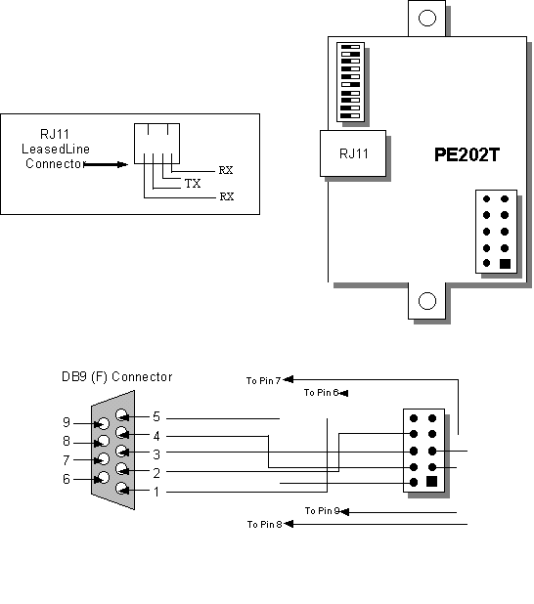
- CONNECTOR PIN-OUTS

Connecting Power to your PE202T

The DC supply voltage is connected to Pins 1 & 6 of the 10-pin header. With your PE evaluation unit you have a ribbon cable to connect the header to a DB9 connector. The two flying leads are connected to header Pins 1 & 6 for power connection
Pin 10  CD | Pin 5  DSR
Pin 9  RxD | Pin 4  RTS
Pin 8  RxD | Pin 3  CTS
Pin 7  DTR | Pin 2  RI  Pin 1
Pin 6  Ground | Pin 1  + Power

8. DIP SWITCH FUNCTIONS
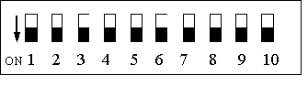

Table 1

Switch | Function | ON | OFF
Switch 1 Switch 1 | Transmit Analog (TxA) Signal Level | 0 dBm | -10 dBm
Switch 2 | Anti-Streaming | 45 secs | OFF
Switch 3 | Received Analog (RxA) Signal Level | -33 dBm | -43 dBm
Switch 4 | RTS/CTS Delay | See Table 2
Switch 5 | RTS/CTS Delay | See Table 2
Switch 6 | Switched/Constant Carrier | Constant Carrier | Switched Carrier (Follows RTS State)
Switch 7 | 2 or 4- Wire Selection | 2-Wire | 4-Wire
Switch 8 | Line Termination | 600 ohms | None (22kohms)
Switch 9 | Soft Carrier (900Hz) Turn Off | ON | OFF
Switch 10 | Spare

Table 2: RTS/CTS Delay Time

2  Wire | 4  Wire | Switched  Carrier | Constant  Carrier | Switch 4 | Switch 5 | Switch 9  Soft Carrier | RTS/CTS  Delay  Time
NO | YES | YES | YES | ON | ON | OFF | 50 ms
YES | NO | YES | NO | ON | ON | ON | 50 ms
NO | YES | YES | NO | ON | ON | ON | 50 ms
YES | NO | YES | NO | ON | ON | OFF | 50 ms
NO | YES | YES | YES | OFF | ON | OFF | 35 ms
NO | YES | YES | NO | OFF | ON | ON | 55 ms
YES | NO | YES | NO | OFF | ON | ON | 35 ms
YES | NO | YES | NO | OFF | ON | OFF | 35 ms
NO | YES | YES | YES | ON | OFF | OFF | 12 ms
NO | YES | YES | NO | ON | OFF | ON | 35 ms
YES | NO | YES | NO | ON | OFF | ON | 12 ms
YES | NO | YES | NO | ON | OFF | OFF | 12 ms
NO | YES | NO | YES | OFF | OFF | OFF | 1 ms
NO | YES | YES | NO | OFF | OFF | OFF | 12 ms
NO | YES | YES | NO | OFF | OFF | ON | 32 ms
YES | NO | YES | NO | OFF | OFF | OFF | 1 ms
YES | NO | YES | NO | OFF | OFF | ON | 1 ms

9. MODEM CONFIGURATION

The following table provides the Dip Switch settings required for most modem application configurations:

 | Dip Switch Setting
 | 1 | 2 | 3 | 4 | 5 | 6 | 7 | 8 | 9
4-Wire  Point-to-Point | ON |  | ON |  |  | ON |  | ON
4-Wire  Multi-Point  Master | ON |  | ON |  |  | ON |  | ON
4-Wire  Multi-Point  Slave  Rx Term. OFF | ON | ON | ON | ON |  |  |  |  | ON
4-Wire  Multi-Point  Slave  Rx Term. ON | ON | ON | ON | ON |  |  |  | ON | ON
2-Wire  Point-to-Point | ON | ON | ON | ON |  |  | ON | ON | ON
2-Wire  Multi-Point  Master  Line Term. ON | ON | ON | ON |  | ON |  | ON | ON | ON
2-Wire  Multi-Point  Slave  Line Term. ON | ON | ON | ON |  | ON |  | ON | ON | ON
2-Wire  Multi-Point  Slave  Line Term. OFF | ON | ON | ON |  | ON |  | ON |  | ON
For clarity, a blank space = OFF

10. OUTLINE DRAWING

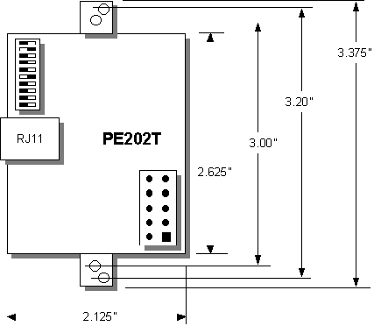

11. DIAGNOSTICS

The following pages provide hardware techniques for diagnosing communication problems and thereby isolating the problem at the local modem, the remote modem or the interconnecting line.

(a) LOCAL ANALOG LOOPBACK (Figure 2)

Requires a loop back cable with a built-in circuit for line loss to simulate a typical leased line condition (See Figure 3).

Connect the loop back cable to the RJ11 connector on the modem under test.

Set Dip Switches as follows…

Switch 7 = OFF 4-Wire
Switch 9 = ON Soft Carrier Turn Off Enabled
Switch 1 = ON Transmit (TxA) Signal Level = 0dBm
Switch 3 = ON Receive (RxA) Signal Level = –33dBm
Switch 6 = OFF Switched Carrier
Switch 4&5 = ON RTS/CTS Delay = 50ms

Test 1: RTS/CTS Analog Control

Set RTS “ON” and check that CD (Carrier Detect) turns “ON”.

Turn RTS “OFF” and ensure that CD turns “OFF”

With RTS “ON”, run a test message at TxD and verify that the same message is received at RxD with no data errors.

Test 2: Transmit Signal Power & Receive Levels

Set Dip Switch 1 OFF (TxA = -10dBm)
CD will be OFF.
Change Dip Switch 1 to ON (TxA = 0dBm)
CD should now be ON.

Test 3: Received Signal Level

Set Dip Switch 1 OFF (TxA = -10dBm) and Dip Switch 3 OFF (RxA = -43dBm).

CD will be ON.

Run a test message at TxD and verify that the same message is received at RxD with no data errors.

Test 4: Repeat Test 3 for various RTS/CTS delay times and with soft carrier ON and OFF.

(b) LOCAL DIGITAL LOOPBACK – 4/Wire Network (Figure 4)

On the modem under test, connect TxD to RxD

Switch 1 = ON (TxA = 0dBm)
Switch 3 = ON (RxA = -33dBm)
Switch 4 = OFF (RTS/CTS = 35ms)
Switch 5 = ON (RTS/CTS = 35ms)
Switch 6 = ON (Constant Carrier mode).
Switch 7 = OFF (4-Wire)
Switch 8 = ON (Line Termination = 600 ohms)
Switch 9 = ON (Soft Carrier = ON)

Transmit a test message from a remote modem and confirm that the same message is received back at RxD on the remote modem with no data errors.

- REMOTE DIGITAL LOOPBACK – 4/Wire Network (Figure 5)

Configure both the local and remote modems as follows:

Switch 1 = ON (TxA = 0dBm)
Switch 3 = ON (RxA = -33dBm)
Switch 4 = OFF (RTS/CTS = 35ms)
Switch 5 = ON (RTS/CTS = 35ms)
Switch 6 = ON (Constant Carrier mode).
Switch 7 = OFF (4-Wire)
Switch 8 = ON (Line Termination = 600 ohms)
Switch 9 = ON (Soft Carrier Turn Off = ON)

Connect TxD to RxD at the remote modem.

Transmit a test message from the local modem and confirm that the same message is received back at RxD on the local modem with no data errors.

- LINE DIAGNOSTICS

(i) Typical modem configuration for 4-wire Point-to-Point system…

Switch 1 = ON (TxA = 0dBm)
Switch 3 = ON (RxA = -33dBm)
Switch 4 = OFF (RTS/CTS = 1ms)
Switch 5 = OFF (RTS/CTS = 1ms)
Switch 6 = ON (Constant Carrier mode).
Switch 7 = OFF (4-Wire)
Switch 8 = ON (Line Termination = 600 ohms)
Switch 9 = OFF (Soft Carrier = OFF)

(ii) Typical modem configuration for 4-wire Multi-Point system…

Switch 1 = ON (TxA = 0dBm)
Switch 3 = ON (RxA = -33dBm)
Switch 4 = OFF (RTS/CTS = 1ms)
Switch 5 = OFF (RTS/CTS = 1ms)
Switch 6 = ON (Constant Carrier mode).
Switch 7 = OFF (4-Wire)
Switch 8 = ON (Line Termination = 600 ohms)
Switch 9 = OFF (Soft Carrier = OFF)

Adjustments…

In a network with high line loss (greater than 16dB) change Switch 3 (RxA) to OFF (-43dBm).

If there are conditions that can cause cross-talk (TxA leaking into RxA path) set Switch 1 (TxA) to OFF (-10dBm).

Note that noise level should be –50dBm or lower for most FSK operation (signal-to-noise ratio of 15dB or higher)
