Data Connect

Installation, Operation & Diagnostics

for the

MIU2.4

MIU9.6

MIU14.4
MIU28.8

Industrial Grade Dial Modems

Book 1 of 2
(See Book 2 for AT Commands)

TABLE of CONTENTS

- STANDARDS Page 2

- PRODUCT OVERVIEW Page 3

- GENERAL PRODUCT SPECIFICATIONS Page 5

- POWER MODES Page 6

- MODEM SPECIFICATIONS Page 7

- POWER CONNECTIONS Page 8

- SERIAL DATA PORT PIN-OUTS Page 9

- DIP SWITCHES Page 10

- LED INDICATOR Page 11

- AUTO RESET FEATURE Page 11

- AUTO DIAL FEATURE Page 11

- OUTLINE DRAWING & MOUNTING Page 12

- MODEM CONFIGURATION Page 13

- FACTORY CONFIGURATION Page 14 - 17

- DIAGNOSTICS Page 18 – 28

1. STANDARDS

All Data Connect dial-up modems are designed to meet the following Standards:

USA: FCC Part 15, Class A and Part 68

Canada: DOC Standards CS-01, CS-02 and CS-03

CANADIAN DEPARTMENT OF COMMUNICATION NOTICE

NOTICE: The Canadian Department of Communications (DOC) label identifies certified equipment. This certification means that the equipment meets certain telecommunications network protective, operational and safety requirements. The department does not guarantee the equipment will operate to the user’s satisfaction.

Before installing this equipment, make sure you are permitted to connect it to the facilities of the local telecommunications company. You must install the equipment using an acceptable method of connection. In some cases you may also extend the company’s inside wiring for single line individual service by means of certified connector assembly (telephone extension cord). You should be aware, however, that compliance with the above conditions may not prevent degradation of service in some situations.

Repairs to certified equipment should be made by an authorized Canadian maintenance facility designed by the supplier. Any repairs or alterations made by a user to this equipment, or equipment malfunctions, may give the telephone communications company cause to request the user to disconnect the equipment.

For your own protection, make sure that the electrical ground connections of the power utility, telephone lines and internal metallic water pipe system, if present, are connected together. This precaution may be particularly important in rural areas.

Caution: Do not attempt to make electrical ground connections yourself, contact the appropriate electric inspection authority or an electrician.

NOTICE: The load number (LN) assigned to each terminal device denotes the percentage of the total load to the telephone loop used by the device, to prevent overloading. The termination on a loop may consist of any combination of devices, subject to the requirement that the total of the load numbers of all the devices does not exceed 100.

2. PRODUCT OVERVIEW

The MIU2.4, MIU9.6, MIU14.4 & MIU28.8 are industrial grade dial modems for connection to the Public Switched Telephone Network.. They can be powered from a wide range of AC and DC power supplies, they are internally surge protected on both the power and analog lines, and they will operate in temperatures from -40 to +85 deg C.

Internally, each unit consists of a baseboard and a communication module. The baseboard includes the power supply regulation and surge protection. The communication module is a Data Connect™ Pony Express™ Dial Modem Module.

The MIU is packaged specifically for the harsh environments found in utility substations and industrial facilities. Though functionally similar to commercial modems, the MIU includes special features that make it particularly well suited for utility and industrial applications:

Environment: The MIU has been designed specifically for use in harsh environments. In addition to an extended temperature range (-40 to +85º C), the MIU includes surge, shock, vibration, and safety features superior to those of conventional commercial modems.

Power Supply: The MIU can be powered from a broad range of AC and DC power supplies, such as an auxiliary supply (eg; 12VDC) from another piece of equipment, 125VDC from a station battery or a standard 120VAC.

Low Power: The MIU dial modem can be configured to enter into a “power down” mode. In this mode, an MIU will consume only a small fraction of its active power while waiting for either controller or telephone activity.

Industrial: The MIU is packaged in a rugged, compact, non-metallic (ABS) enclosure. Designed for unmanned locations, the MIUs do not include the array of pushbuttons and LEDs normally associated with consumer-type modems. Configuration is by dip switches and/or software (“AT”) commands. Standard industrial connectors for data, analog and power interfaces allow reliable interconnection to other industrial components.

3. GENERAL PRODUCT SPECIFICATIONS

Dimensions: 5.3 x 4.0 x 1.375 inches
Weight: 1 lb

Voltage Supply: Standard Model: 40 to 270VDC
40 to 270VAC, 50/60Hz
LV Model (Suffix “-LV”): 9 to 36VDC

Current Requirements: (See Section 4 for Power Down Modes)

MIU2.4:

12VDC 24VDC 125VDC 120VAC 220VAC
65mA 27mA 7.5mA 6.5mA 5.5mA

MIU9.6:

12VDC 24VDC 125VDC 120VAC 220VAC
115mA 57mA 11mA 10mA 9mA

MIU14.4:

12VDC 24VDC 125VDC 120VAC 220VAC
160mA 69mA 14mA 12mA 9mA

MIU28.8:

12VDC 24VDC 125VDC 120VAC 220VAC
205mA 125mA 16mA 15mA 11mA

Surge Protection: Power Supply: 8kVrms
Analog Line: 5kVac (MIU2.4 & 9.6)
3.75kVac (MIU14.4 & 28.8)
Digital Line: ESD ± 10kV

Operating Temperature: -40 to +85 deg C
Operating Humidity: 0 to 90% (non-condensing.)
Storage Temperature: -55 to 100 deg C

4. POWER MODES

Mode | Description | Power  Consumption
Power On | Factory Setting: Full power is always available to the modem. | See Section 3
Sleep | If the modem is on hook for a  predetermined period (PE2400 = 5  seconds; PE2496, PE14.4 & PE28.8 =  software configured: Set S24 to desired  delay in seconds), it will drop to a low current mode).  The modem will instantly “wake up” to full power by either an incoming ring signal or any transmit data (TxD) signal. | Approx. 6mA
Power Down | If the modem is on hook for 30 seconds,  it will automatically turn “off”.  The modem will automatically turn “on” to full power within 400ms of receiving a DTR signal or an incoming call. | Approx. 20μA

The power mode is set by a dip switch on the Pony Express Modem Module inside the MIU case. Factory default is Power On mode. Other modes are set at the factory before shipment if requested. Other modes can be set in the field ~ call Data Connect for an instruction sheet.

5. MODEM SPECIFICATIONS

 | MIU2.4 | MIU9.6 | MIU14.4 | MIU28.8
Standards | V.22bis  V.22  Bell212A  Bell 103 | V.22bis  V.22  Bell212A  Bell 103 | V.32bis  V.32  V.22bis  V.22  Bell212A  Bell 103 | V.34  V.32bis  V.32  V.22bis  V.22  Bell212A  Bell 103
Modem Line  Speed  (Asynch) | 2400bps  1200bps  300bps | 2400bps  1200bps  300bps | 14400bps  9600bps  4800bps  2400bps  1200bps  300bps | 28800bps  19200bps  14400bps  9600bps  4800bps  2400bps  1200bps  300bps
DTE Rates  above Modem  Line Speeds | - | 19200bps  9600bps  4800bps | 57600bps  38400bps  19200bps | 115200bps  57600bps  38400bps  19200bps
Error  Correction &  Data  Compression | - | MNP 2,3,5  & 10  V.42  V.42bis | MNP 2,3,5  & 10  V.42  V.42bis | MNP 2,3,5  & 10  V.42  V.42bis

6. POWER CONNECTIONS
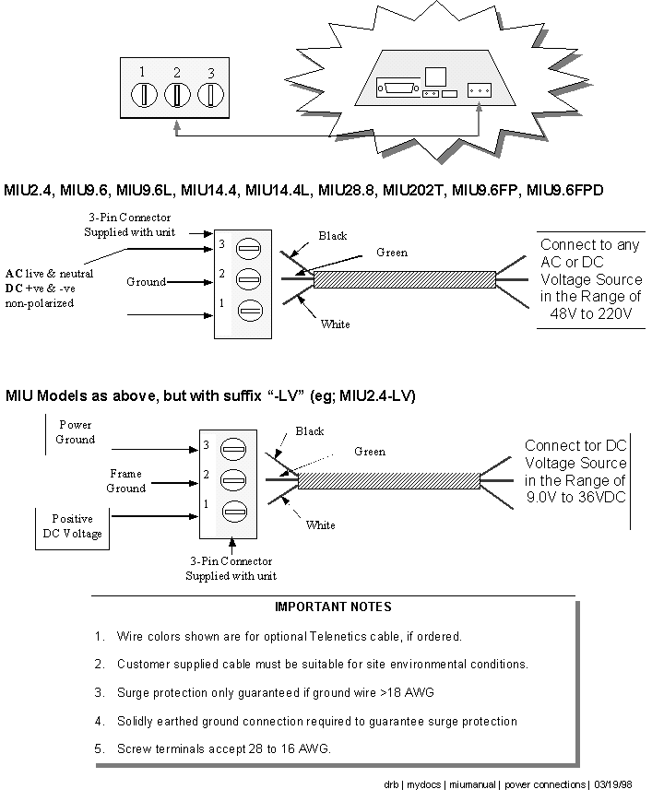

7. SERIAL DATA PORT PIN-OUTS

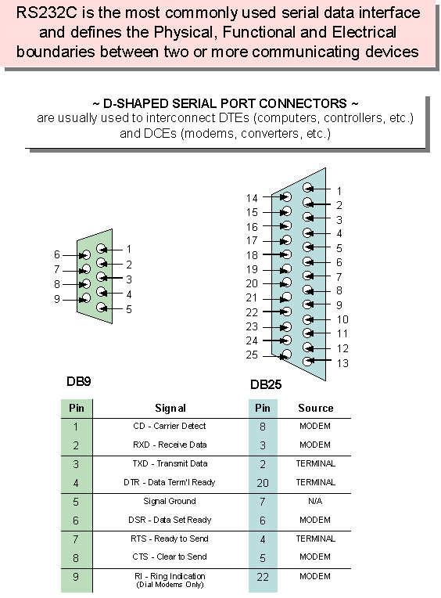

8. DIP SWITCH SETTINGS

Not Applicable

9. LED INDICATOR

The MIU has a single LED that will indicate the following conditions...

 Blinking: POWER ON

 Steady: MODEM CONNECTED (CARRIER DETECT)

10. AUTO RESET FEATURE

The dial-up modem modules inside your MIU include an “Auto Reset” feature: If the modem configuration is lost for any reason, it can be restored by dialing the modem and allowing it to ring 4 to 6 times.

The Auto Reset feature is enabled and disabled by a dip switch on the modem module. Your MIU will have been shipped with the Auto Reset mode active, unless otherwise specified at the time of ordering. Please consult Data Connect if you wish to open up your MIU to disable Auto Reset.

11. AUTO DIAL FEATURE

The dial-up modem modules inside your MIU include a software configured “Auto Dial” feature: Command AT\D1 will enable Auto Dial: When DTR goes from an OFF to ON condition, and \D1 is set, the modem will auto dial the phone number stored in location & Z0 (up to 45 digits).

Command \D0 (default) will disable the Auto Dial feature.

- OUTLINE DRAWING & MOUNTING

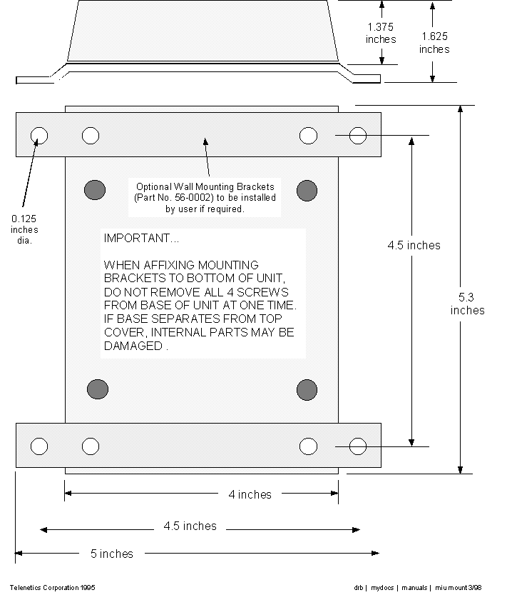

13. MODEM CONFIGURATION

Data Connect dial and leased line modems are based upon Rockwell chipsets. These chipsets contain Rockwell’s “AT” command set.

A summary of the Rockwell command set for your MIU modem is provided in Book 2.

Unless otherwise specified at the time of order, your modem will have left the Data Connect factory in the configuration detailed on the following pages.

The Data Connect factory configuration differs from the Rockwell default configuration as follows...

&C0 Rockwell Default Carrier Detect (CD) always ON.
&C1 Data Connect Factory Carrier Detect (CD) only ON
when modem connected (on hook)

S0=0 Rockwell Default Auto-Answer OFF
S0=1 Data Connect Factory Auto-Answer on first ring

You can review the configuration of your modem by entering AT&V
<CR>.

You can restore the Rockwell factory configuration by entering
AT&F&W

14. FACTORY CONFIGURATION ~ MIU2.4

ACTIVE PROFILE:
B1 E1 L2 M1 Q0 V1 X4 Y0 &C1 &D0 &G0 &J0 &L0 &P0 &Q0
&R0 &S0 &X0 &Y0 S00:001 S01:000 S02:043 S03:013 S04:010
S05:008 S06:002 S07:030 S08:002 S09:006 S10:014 S12:050
S14:AAH S16:00H S S18:000 S21:00H S22:76H S23:15H S25:005
S26:001 S27:40H S28:00H

STORED PROFILE 0:
B1 E1 L2 M1 Q0 V1 X4 Y0 &C1 &D0 &G0 &J0 &L0 &P0 &Q0
&R0 &S0 &X0 S00:001 S14:AAH S18:000 S21:00H S22:76H
S23:17H S25:005 S26:001 S27:40H S28:00H

STORED PROFILE 1:
B1 E1 L2 M1 Q0 V1 X4 Y0 &C0 &D0 &G0 &J0 &L0 &P0 &Q0
&R0 &S0 &X0 S00:000 S14:AAH S18:000 S21:00H S22:76H
S23:17H S25:005 S26:001 S27:40H S28:00H

TELEPHONE NUMBERS
&Z0=
&Z1=
&Z2=
&Z3=

14. FACTORY CONFIGURATION ~ MIU9.6

ACTIVE PROFILE:
B1 E1 L1 M1 N1 Q0 T V1 W0 X4 Y0 &C1 &D2 &G0 &J0 &K3
&Q5 &R1 &S0 &T5 &X0 &Y0 S00:001 S01:000 S02:043 S03:013
S04:010 S05:008 S06:002 S07:050 S08:002 S09:006 S10:014
S11:095 S12:050 S18:000 S25:005 S26:001 S36:007 S37:000
S38:020 S44:020 S46:138 S48:007 S95:000

STORED PROFILE 0:
B1 E1 L1 M1 N1 Q0 T V1 W0 X4 Y0 &C1 &D2 &G0 &J0 &K3
&Q5 &R1 &S0 &T5 &X0 S00:001 S02:043 S06:002 S07:050
S08:002 S09:006 S10:014 S11:095 S12:050 S18:000 S36:007
S37:000 S40:168 S41:195 S46:138 S95:046

STORED PROFILE 1:
B1 E1 L1 M1 N1 Q0 T V1 W0 X4 Y0 &C1 &D2 &G0 &J0 &K3
&Q5 &R1 &S0 &T5 &X0 S00:001 S02:043 S06:002 S07:050
S08:002 S09:006 S10:014 S11:095 S12:050 S18:000 S36:007
S37:000 S40:168 S41:195 S46:138 S95:000

TELEPHONE NUMBERS:
0= 1=
2= 3=

14. FACTORY CONFIGURATION ~ MIU14.4

ACTIVE PROFILE:
B1 E1 L1 M1 N1 Q0 T V1 W0 X4 Y0 &C1 &D2 &G0 &J0 &K3
&Q5 &R1 &S0 &T5 &X0 &Y0 S00:001 S01:000 S02:043 S03:013
S04:010 S05:008 S06:002 S07:050 S08:002 S09:006 S10:014
S11:095 S12:050 S18:000 S25:005 S26:001 S36:007 S37:000
S38:020 S44:020 S46:138 S48:007 S95:000

STORED PROFILE 0:
B1 E1 L1 M1 N1 Q0 T V1 W0 X4 Y0 &C1 &D2 &G0 &J0 &K3
&Q5 &R1 &S0 &T5 &X0 S00:001 S02:043 S06:002 S07:050
S08:002 S09:006 S10:014 S11:095 S12:050 S18:000 S36:007
S37:000 S40:168 S41:195 S46:138 S95:046

STORED PROFILE 1:
B1 E1 L1 M1 N1 Q0 T V1 W0 X4 Y0 &C1 &D2 &G0 &J0 &K3
&Q5 &R1 &S0 &T5 &X0 S00:001 S02:043 S06:002 S07:050
S08:002 S09:006 S10:014 S11:095 S12:050 S18:000 S36:007
S37:000 S40:168 S41:195 S46:138 S95:000

TELEPHONE NUMBERS:
0= 1=
2= 3=

14. FACTORY CONFIGURATION ~ MIU28.8

ACTIVE PROFILE:
B0 E1 L1 M1 N1 Q0 T V1 W0 X4 Y0 &C1 &D0 &G2 &J0 &K3
&Q5 &R1 &S0 &T4 &X0 &Y0 S00:001 S01:000 S02:043 S03:013
S04:010 S05:008 S06:002 S07:030 S08:002 S09:006 S10:014
S11:255 S12:050 S18:000 S25:005 S26:001 S36:007 S37:000
S38:020 S46:138 S48:007 S95:000

STORED PROFILE 0:
B0 E1 L1 M1 N1 Q0 T V1 W0 X4 Y0 &C1 &D0 &G2 &J0 &K3
&Q5 &R1 &S0 &T4 &X0 S00:001 S02:043 S06:002 S07:030
S08:002 S09:006 S10:014 S11:095 S12:050 S18:000 S36:007
S37:000 S40:105 S41:003 S46:138 S95:000

STORED PROFILE 1:
B0 E1 L1 M1 N1 Q0 T V1 W0 X4 Y0 &C1 &D0 &G2 &J0 &K3
&Q5 &R1 &S0 &T4 &X0 S00:001 S02:043 S06:002 S07:030
S08:002 S09:006 S10:014 S11:095 S12:050 S18:000 S36:007
S37:000 S40:105 S41:003 S46:138 S95:000

TELEPHONE NUMBERS:
0= 1=
2= 3=

15. DIAGNOSTICS

The following pages provide software and hardware techniques for diagnosing communication problems and thereby isolating the problem at either the local modem, the remote modem or the interconnecting line.

The following AT&Tn commands form part of the CCITT V.54 protocol and can be used for diagnostic testing.

Note: &Tn commands can only be used when the modem is configured for &Q0 <CR> (unbuffered/direct asynchronous mode).

&T0 TERMINATE TEST IN PROGRESS

If a V.54 loopback test is in progress as a result of executing an &Tn command, then the &T0 command will cause that test to be terminated, provided that the modem is in the command state or a V.54 state that accepts commands from the DTE. See specific &Tn command descriptions for termination actions.

&T1 INITIATE LOCAL ANALOG LOOPBACK (See Figure 2)

When the AT&T1 command is entered, the modem goes on hook and configures itself for analog loopback. DSR is turned off (if &S1 is in effect), the analog loopback state is entered, and the test timer is set to the value in S18. A connect result code is sent to the DTE, and the test timer then begins its count down. The test terminates when the test timer expires. If S18 equals 0, then the test must be terminated by an &T0, H0, or Z command. While any command may be entered while the modem is in this test state, the modem response is not specified except for H0, &T0 and Z, any of which will terminate the test. Upon termination of the test, the modem enters the command state.

RESULT CODE DESCRIPTION

CONNECT When local analog loopback state is
entered.
ERROR If any other &Tn test is active (except
&T0) or if in the on-line command
state.
OK After test is stopped by test timer, the
H0 command, or the &T0 command.

&T2 NO FUNCTION

&T3 PERFORM LOCAL DIGITAL LOOPBACK (See Figure 3)

The modem must be in the command state with connection established when this command is issued, otherwise an ERROR result code occurs.

The AT&T3 command establishes a loopback of received data, after demodulation, and sends it back to the distant end. The modem is configured for local digital loopback, DSR is turned off (if &S1 is in effect), the test timer is started with the value in S18, and an OK result code is sent to the DTE. If S18 contains a 0, the test must be terminated by a &T0, H0, or Z command. The latter two result in the modem going on hook. If S18 does not contain 0, the test is terminated after the number of seconds stored in S18.

RESULT CODE DESCRIPTION

OK After 2 second delay
ERROR If any other self test is active (&T1,
&T6, &T7 or &T8) or if in idle state.
When test is terminated.

&T4 GRANT REMOTE DIGITAL LOOPBACK (RDL) REQUESTS

When in the on-line state, the modem will honor a remote digital loopback request from a distant modem if it occurs. This will result in an ERROR if the command is given while any V.54 test is active (&T1, &T3, &T6, &T7 or &T8).

NOTE: There are data patterns that may cause a Remote Digital Loopback conditions. Care should be given to the type of data being received so that no RDL modes will be initiated.

&T5 DENY RDL REQUESTS

The modem will not respond to a remote digital loopback request from a distant modem. This will result in an error if the command is given while any V.54 test is active (&T1, &T3, &T6, &T7 or &T8).

&T6 INITIATE REMOTE DIGITAL LOOPBACK (See Figure 4)

The command is valid only if the modem is in the command state with a connection established.

Configure the modem under test with an AT&T4 command so that it will honor a remote digital loopback request.

Enter AT&T6 at the local modem and it will send a remote digital loopback request to the remote modem. After the RDL acknowledgement signal is received from the remote modem, DSR is turned off (if &S1 is in effect), the on-line state is entered, a CONNECT result code is sent to the DTE, and the test timer is set to the value in S18.

If the local modem does not receive the RDL acknowledgment signal from the remote end in three seconds, it sends an ERROR result code to the DTE and returns to the command state. The local modem sends the
signal to release the remote digital loopback when the test is terminated.

The test may be terminated by the H0, Z, or &T0 command. The test will also terminate when the test timer expires (sending the modem to the command state) or carrier is lost (causing a NO CARRIER result code and the modem to go on hook in the command state).

RESULT CODE DESCRIPTION

CONNECT When on-line state is entered.
ERROR If any V.54 test is active (&T1, &T3,
&T6-&T8).
ERROR If not in on-line command state.
ERROR If the RDL signal is not acknowledged.

&T7 INITIATE RDL WITH LOCAL SELF TEST (See Figure 5)

This is a system test, end to end.

The command is valid only if the modems are in the command state with a connection established.

Configure the remote modem with an AT&T4 command so that it will honor a remote digital loopback request.

Enter AT&T7 at the local modem and it will send a digital loopback request to the remote modem. After the RDL acknowledgment signal is received from the remote modem, DSR is turned off (if &S1 is in effect), the on-line state is entered, an OK result code is sent to the DTE, and the test timer is set to the value in S18. While the test is active, the local modem sends a test message to the remote modem and counts the errors in the received (looped back) signal. The modems stay in the command state during the test. When the test is terminated (except by a loss of carrier), the local modem sends the release signal to the remote modem, as in &T6, and reports the three-digit error count to the DTE.

The information text is followed by an OK result code. The test is terminated by loss of carrier, or an H0, &T0, or Z command, and by the S18 timer running out.

RESULT CODES DESCRIPTION

OK When command executed is started.
OK After error count is sent to DTE (&T1,
&T3, &T6, &T7 or &T8).
ERROR If not in on-line command state.
ERROR If the RDL signal is not acknowledged.

&T8 LOCAL LOOPBACK WITH SELF TEST (See Figure 6)

The modem should be on hook. Enter AT&T8 to configure the modem for analog loopback and self test. The test timer is started at the time indicated by S18, DSR is turned off (if &S1 is in effect). A self test condition is entered, and an OK result code is sent to the DTE. During the test the modem sends a test message and counts errors in the looped
back signal. The test is terminated when the timer times out (S18) or the &T0, H0, or Z command is issued. When the test is terminated, the three digit error count is sent to the DTE. An OK result code follows the error count.

RESULT CODE DESCRIPTION

OK If a test state is entered.
OK After error count is sent to DTE
ERROR If any other V.54 test is active (&T1, &T3, &T6, &T7), or if on-line.
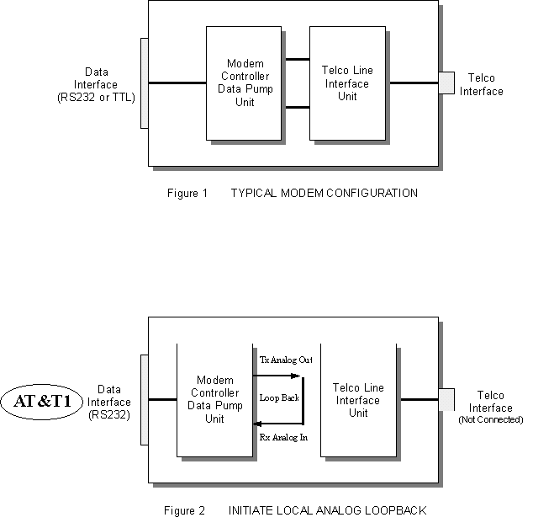
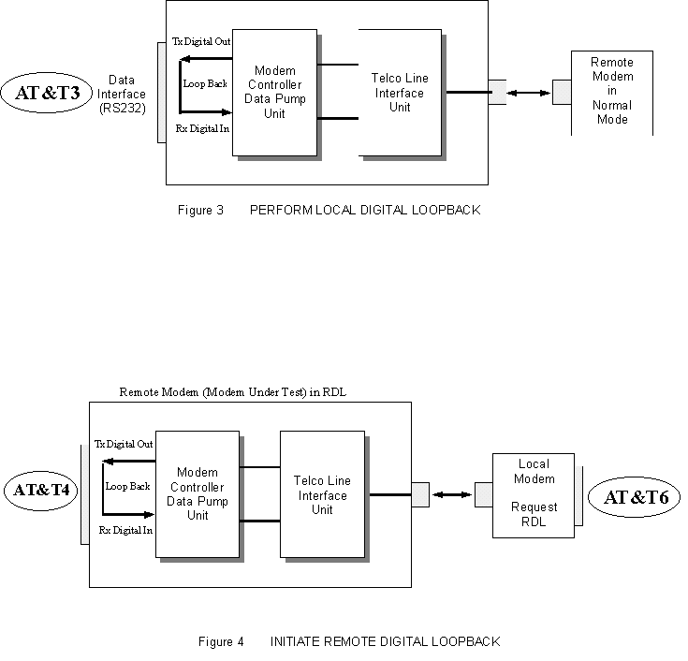
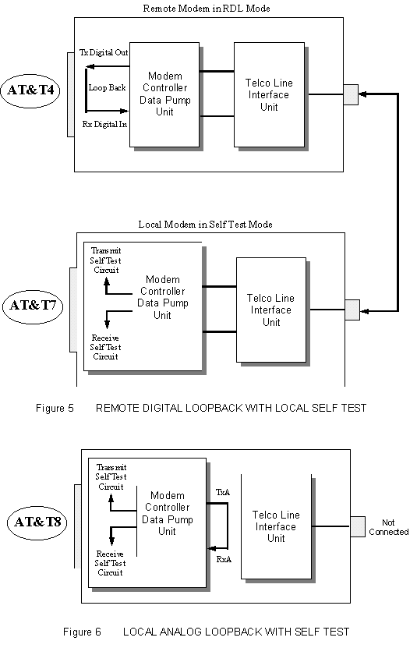

ADDITIONAL TEST / DIAGNOSTICS COMMANDS...

%L RECEIVED SIGNAL LEVEL

Returns a value (-dBm) which indicates the received signal
level at modem DATA PUMP interface. This value is determined by the loss/gain of modem Telco Interface circuit ±dB at the Tip/Ring input to the modem. Typical value should be -25dBm to -35dBm for most Telco connections.

%Q RECEIVED LINE SIGNAL QUALITY

Reports the line signal quality at the modem DATA PUMP
interface. This signal is also dependent on the DAA circuit
(Telco Interface). Returns the higher order byte of the EQM (Eye Quality Monitor is the filter squared magnitude of the error vector). Typical value should be below 10. The lower the number, the better the performance from the modem.

ERROR response if NO connection to remote modem.

In &T1, modem %Q will be 0.

S86 CONNECTION FAILURE CAUSE

S86 can help determine the cause of a connection failure.
When the modem issues a NO CARRIER result code, a value is written to this register. To read this register, following the connection failure, issue ATS86? <CR>. The modem will report one of the following values...

0 Normal hang up; no error occurred.
4 Physical carrier loss. (Loss of Carrier)
5 Feature negotiation failed to detect presence of another V.42 error-control modem at other end.
6 Other error-control modem did not respond to
feature negotiation message sent by this modem.
7 Other modem is synchronous-only; this modem is asynchronous-only.
8 Modems could not find a common framing technique.
9 Modems could not find a protocol in common.
10 Feature negotiation message sent by other modem incorrect.
11 Synchronous information (data of flags) not received from other modem.
12 Normal disconnect initiated by other modem.
13 Other modem did not respond after many transmissions of the same message. Modem made 10 attempts then hung up.
14 Protocol violation occurred.
15 Compression failure.

Note: Multiple occurrences may contribute to a NO CARRIER
message; S86 records the first event that occurred.

NOTES:

